Median nerve
- Also called labourers nerve, ‘peripheral eye’
- “Median” in position in forearm
- Supplies most flexors of forearm and thumb muscles
- Median nerve innervates - abductor pollicis brevis and opponens pollicis muscles in hand. Contraction of these muscles gives humans the ability to oppose the thumb joint
- Injury to both ulnar and median nerves results in total claw hand
- Root: C5,6,7,8 and T1

Formation
Union of medial root (branch of medial cord) with lateral root (branch of lateral cord of brachial plexus) – ‘Y’ shaped union

Course
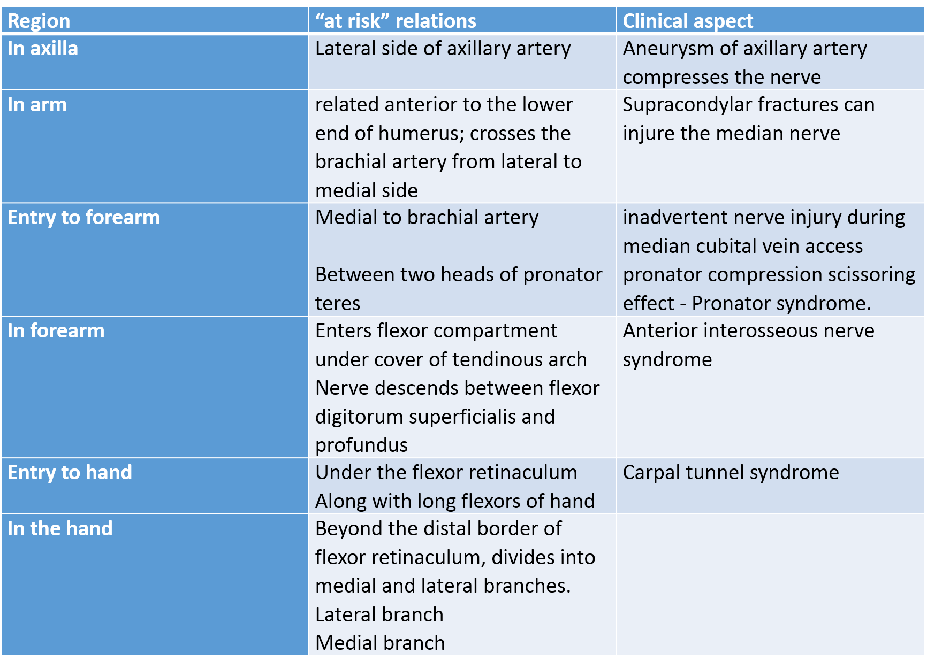
[TIP]Watch and learn to draw the diagram
[YOUTUBE] https://youtu.be/-J820xin50g

Branches
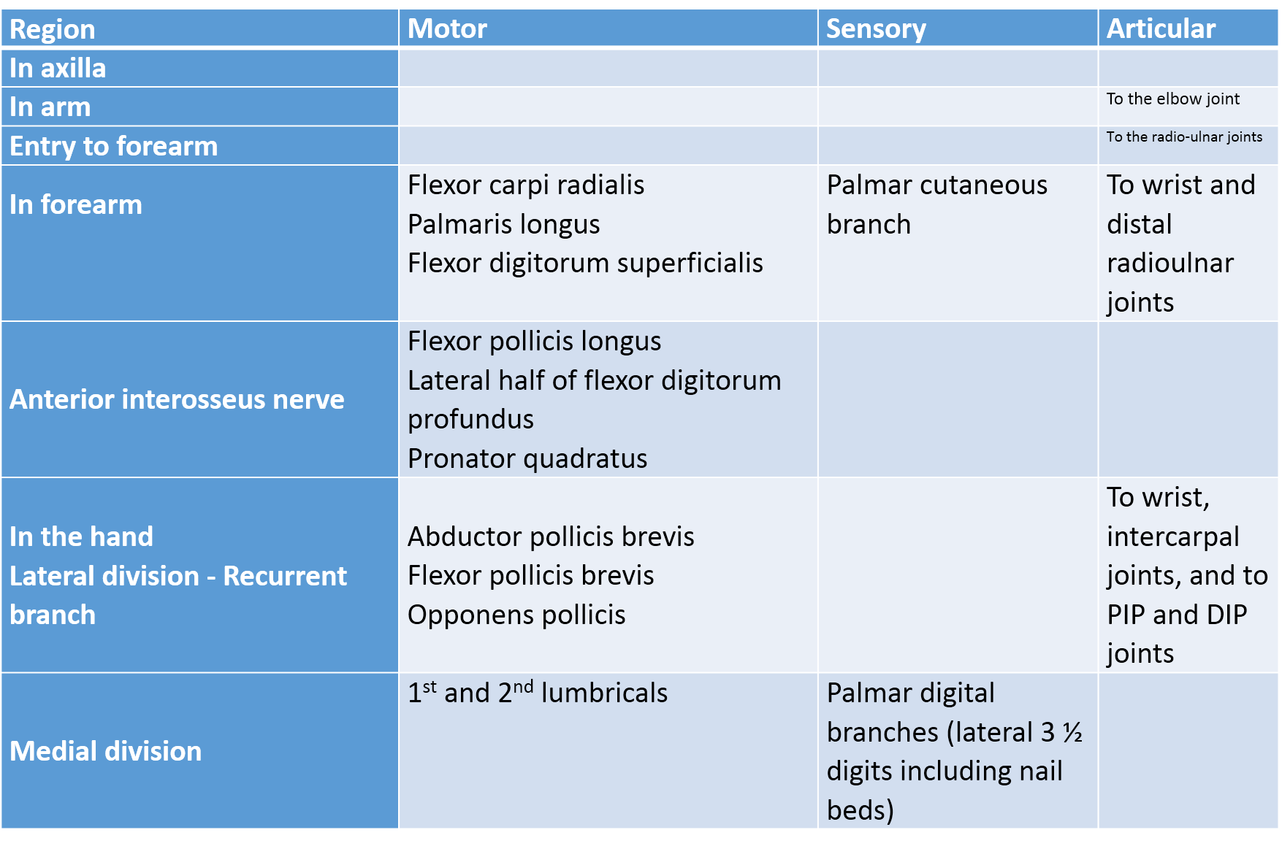
[TIP]Watch and learn to draw the diagram
[YOUTUBE] https://youtu.be/cqlVkFkj6Es

Anterior Interosseous Nerve
- Arises from lateral side of median nerve distal to pronator teres

Innervates
- Flexor pollicis longus
- Pronator quadratus
- Lateral half of flexor digitorum profundus forming digital tendons for index and middle fingers
It ends by supplying distal radioulnar, radiocarpal and carpal articulations

Flexor pollicis brevis
The flexor pollicis brevis has two heads a superficial and a deep.
The superficial is innervated by the median nerve
The deep is innervated by the ulnar nerve

Cutaneous innervation by Median nerve
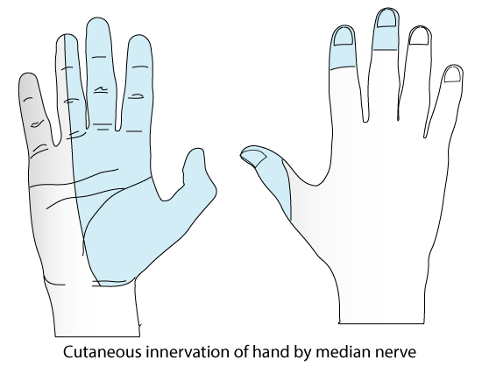

Autonomous zones of median nerve

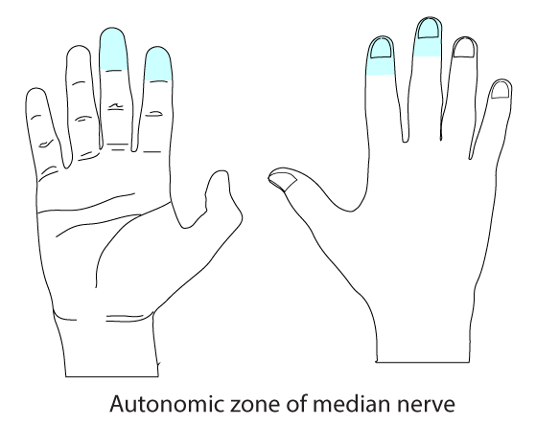

Applied aspects - Tests for detecting median nerve injury
- Pen test- patient is unable to touch the pen held at a distance in horizontal plane, due to the loss of action of abductor pollcis brevis
- Pointing index or Oschner’s clasp test: index and middle finger fail to flex during clasping with both hands. This is due to loss of action of long flexors going to these fingers
- Benediction test: patient is unable to flex the fore finger and middle finger on raising the hand
___MCQ_START___
Q1. In the cubital fossa, the median nerve lies in which position relative to the brachial artery?
A. Lateral to brachial artery
B. Posterior to brachial artery
C. Medial to brachial artery[CORRECT]
D. Superficial to bicipital aponeurosis
___
Q2. Which of the following is a branch of the median nerve in the forearm?
A. Posterior interosseous nerve
B. Anterior interosseous nerve[CORRECT]
C. Deep branch of ulnar nerve
D. Radial nerve
___
Q3. Sensory loss over the palmar aspect of which digits indicates median nerve injury?
A. Medial one and a half digits
B. Lateral one and a half digits
C. Lateral three and a half digits[CORRECT]
D. All five digits
___
Q4. In the pen test for median nerve injury, the patient is unable to touch a pen held in the horizontal plane due to paralysis of:
A. Adductor pollicis
B. Opponens pollicis
C. Abductor pollicis brevis[CORRECT]
D. Flexor pollicis longus
___
Q5. Failure of the index and middle fingers to flex while clasping both hands together is known as:
A. Benediction test
B. Froment’s sign
C. Ochsner’s clasp test[CORRECT]
D. Tinel’s sign
___
Q6. The underlying cause of a positive Ochsner’s clasp test is paralysis of:
A. Lumbricals of ring and little finger
B. Interossei muscles
C. Long flexors of index and middle fingers[CORRECT]
D. Thenar muscles
___
Q7. In Benediction test, inability to flex the index and middle fingers on raising the hand indicates injury to:
A. Ulnar nerve
B. Radial nerve
C. Median nerve[CORRECT]
D. Musculocutaneous nerve
___
Q8. In supracondylar fracture of the humerus, the most commonly injured nerve is:
A. Radial nerve
B. Ulnar nerve
C. Median nerve[CORRECT]
D. Axillary nerve
___
Q9. All the following muscles are supplied by the median nerve EXCEPT:
A. Abductor pollicis brevis
B. Opponens pollicis
C. First lumbrical
D. Adductor pollicis[CORRECT]
___
___MCQ_END___

